Celebration High School
IB Language & Literature HL
Two-Year Course Outline | Cohort 2026–2028
Instructor: Angely Suarez
Room: 7-245
angely.suarezdejesus@osceolaschools.net
All works and schedules are subject to change.

Course Overview
In this course, students study a wide range of literary and non-literary texts in a variety of media. By examining communicative acts across literary form and textual type alongside appropriate secondary readings, students will investigate the nature of language itself and the ways in which it shapes and is influenced by identity and culture. Approaches to study in the course are wide-ranging and can include literary theory, sociolinguistics, media studies, and critical discourse analysis.

What students will learn
- The complex and dynamic nature of language and both its practical and aesthetic dimensions.
- The crucial role language plays in communication, reflecting experience, and shaping the world.
- Their own roles as producers of language, developing productive skills.
- How language choices, text types, literary forms, and contextual elements affect meaning.
- Their own interpretations and the critical perspectives of others, exploring how positions are shaped by cultural belief systems.
- How texts and their visual and audio elements work together to influence audiences.

IB HL Required Works (6 total)
All works comply with IB HL requirements: 6 works total, covering at least 3 literary forms, 3 periods, and 3 countries/regions across 2+ continents. PRL authors verified against the official IB Prescribed Reading List.
IB HL Category | Works Studied (with access links)
Works in Translation  Authors on the IB Prescribed Reading List (PRL). Minimum: 2 works. | 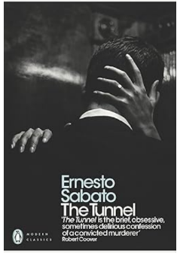  1. The Tunnel by Ernesto Sabato (1956, Argentina) — PRL ✓  Form: Novella | ~150 pages | Spanish (read in translation) | 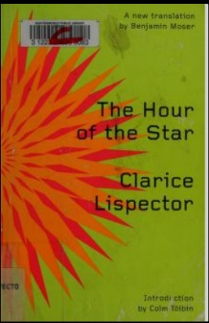  2. The Hour of the Star by Clarice Lispector (1977, Brazil) — PRL ✓  Form: Novella | Portuguese (read in translation)
Works Originally in the Language Studied  Authors on the IB Prescribed Reading List (PRL). Minimum: 2 works. | 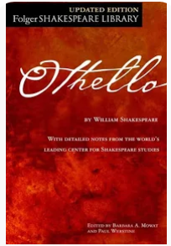  3. Othello by William Shakespeare (1622, UK) — PRL ✓  Form: Tragedy | Folger Shakespeare Library edition (full text, audio, paired-text lesson plans) | 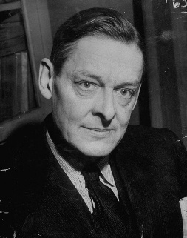  4. Selected Poems by T. S. Eliot (1915–1930, U.S./UK) — PRL ✓  Form: Poetry | 19 poems — full list with links below
Free Choice Works  Any author. Minimum: 2 works. | 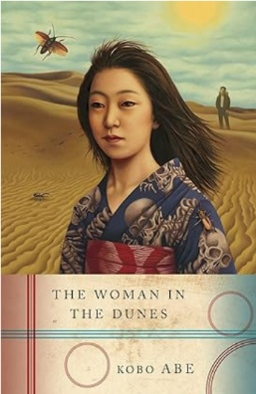  5. The Woman in the Dunes by Kōbō Abe (1962, Japan)  Form: Novel | Japanese (read in translation) | Existentialist  Amazon Link | 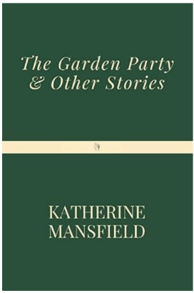  6. Selected Short Stories (6) by Katherine Mansfield (1920–1923, NZ/UK) — PRL ✓  Form: Short fiction | FREE full text — Project Gutenberg | Mansfield is on the PRL
Total Literary Works | 6

IB Concepts & Global Issues — Course Mapping
Every literary work and non-literary text in this course connects to at least one IB course concept and one Global Issue Field of Inquiry. This mapping supports unit planning, IO preparation (where students must analyse a global issue across two texts), and Paper 2 comparative essay practice.

The 7 IB Course Concepts
- Identity — how texts construct, perform, and challenge personal, cultural, and national identities.
- Culture — the social, historical, and ideological contexts that shape and are shaped by texts.
- Creativity — the artistic choices and innovation of writers and producers across literary and non-literary forms.
- Communication — how texts construct meaning between producer and audience.
- Perspective — how point of view, voice, and standpoint shape interpretation.
- Transformation — how texts adapt, rewrite, and respond to other texts and contexts.
- Representation — how language and form (re)present reality, identities, and ideas.

The 5 Global Issue Fields of Inquiry (Required for the IO)
- Culture, identity and community
- Beliefs, values and education
- Politics, power and justice
- Art, creativity and the imagination
- Science, technology and the environment

Literary Works — Concept & Global Issue Map
Each of the 6 required works is mapped to its most relevant IB concepts and a primary Global Issue field of inquiry. A secondary issue is suggested for IO flexibility and Paper 2 pairings.
Work / Form / Context | Connection to IB Concepts | Global Issue (Field of Inquiry)
The Tunnel  Sabato | Novella | Argentina, 1956 | Identity — Castel's fractured, narcissistic self; obsessive consciousness.  Perspective — Unreliable first-person confession; subjective reality.  Communication — The failure of authentic human connection. | Culture, identity and community  Alienation and isolation in modern urban society; the impossibility of being truly known.  Also: Beliefs, values and education (existentialist worldview)
The Hour of the Star  Lispector | Novella | Brazil, 1977 | Identity — Macabéa's invisible existence; the narrator's metafictional self.  Representation — How the marginalised poor are represented; authorial ethics.  Creativity — Metafiction; the act of writing as creation and exposure. | Culture, identity and community  Class, gender, and regional identity (Northeast Brazil → Rio); the invisibility of poverty.  Also: Politics, power and justice (gendered and economic power)
Othello  Shakespeare | Tragedy | UK, 1622 | Identity — Othello's racial and cultural identity; outsider status in Venice.  Transformation — From noble general to murderer through Iago's manipulation.  Perspective — How characters perceive Othello differently; the politics of seeing. | Politics, power and justice  Race, jealousy, and manipulation as instruments of power; gendered violence.  Also: Culture, identity and community (the outsider in society)
Selected Poems  T. S. Eliot | Poetry | US/UK, 1911–1930 | Identity — The fragmented modern self (Prufrock, Gerontion, the Magi).  Transformation — Spiritual transformation in 'Journey of the Magi,' 'The Hollow Men,' 'Marina.'  Representation — Modernist representation of urban alienation and spiritual emptiness. | Beliefs, values and education  Spiritual crisis, modernity vs. tradition, the secular and the sacred.  Also: Art, creativity and the imagination (modernist innovation)
The Woman in the Dunes  Abe | Novel | Japan, 1962 | Identity — Niki's loss and recreation of self in captivity.  Transformation — From urban entomologist to dune dweller; existential reorientation.  Perspective — Existentialist questioning of freedom, conformity, and meaning. | Science, technology and the environment  Sand as nature shaping and trapping humans; environment as agent of change.  Also: Politics, power and justice (the village's authority and individual free will)
Selected Short Stories  Mansfield | Short fiction | NZ/UK, 1920–1923 | Identity — The self-deceiving and constrained self (Miss Brill, the Lady's Maid).  Perspective — Free indirect discourse; the sudden epiphany that reframes a life.  Representation — How class, gender, and ageing are rendered in modernist miniature. | Culture, identity and community  Loneliness, class, and constrained female lives in the modern world.  Also: Politics, power and justice (gender and servitude)

Non-Literary Texts / Bodies of Work — Concept & Global Issue Map
Non-literary text types studied across Year 1 and Year 2. Any of these may serve as the non-literary extract on the IO when paired with one of the 6 literary works.
Text Type / Body of Work | When | IB Concepts | Global Issue
Music (album lyrics) | Y1 Q1 | Communication • Culture • Representation | Art, creativity and the imagination  How popular music shapes and reflects cultural identity, values, and emotion.  Tracy Chapman, Tracy Chapman (1988) — full album  • “Fast Car” — escape planned in the second person  • “Behind the Wall” — unaccompanied voice; violence overheard  • “Talkin’ Bout a Revolution” — the rhetoric of coming change  • “Mountains o’ Things” — consumer desire from below  Profanity-free. Pairs with The Hour of the Star.
Photography — Dorothea Lange | Y1 Q2 | Representation • Perspective • Communication | Politics, power and justice  Great Depression, migrant labor, and the ethics of documentary witness.  Dorothea Lange   Dorothea Lange. White Angel Bread Line, San Francisco. 1933 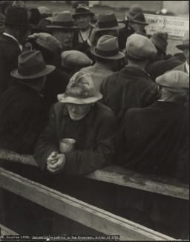  Dorothea Lange. Migrant Mother, Nipomo, California. March 1936 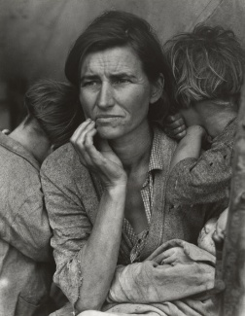  Dorothea Lange. Damaged Child, Shacktown, Elm Grove, Oklahoma. August 1936 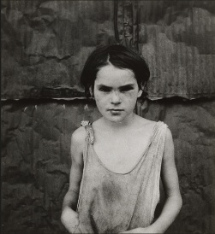  Dorothea Lange. Plantation Overseer and his Field Hands, Mississippi Delta. June 1936 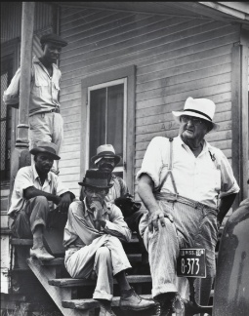  Dorothea Lange. On the Road to Los Angeles, California. March 1937 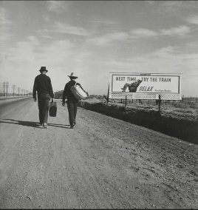  Dorothea Lange. Funeral Cortege, End of an Era in a Small Valley Town, California. 1938 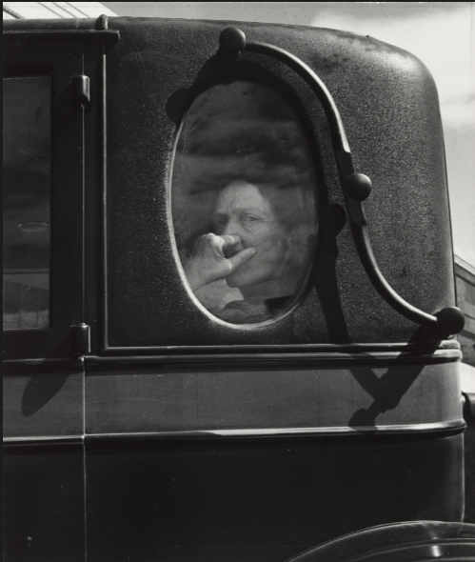  Dorothea Lange. Migrant Mother — frame 1 of 4 (widest). Nipomo, March 1936. The tent, pole, lantern, pie tin and a second camp are all still visible. 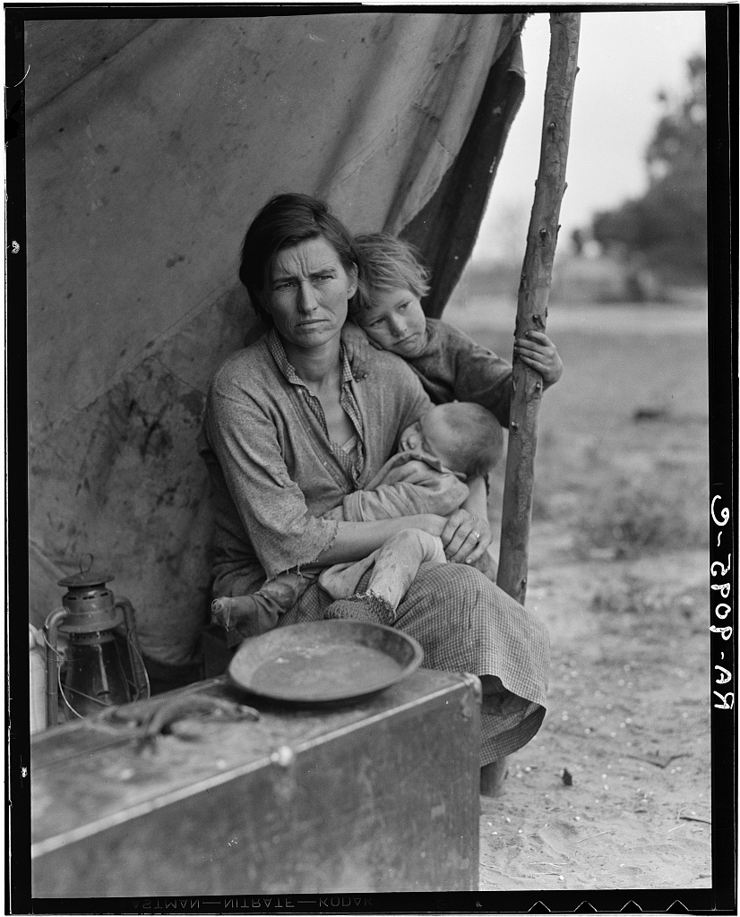  Dorothea Lange. Migrant Mother — frame 2 of 4. Closer; the pole and lantern remain. 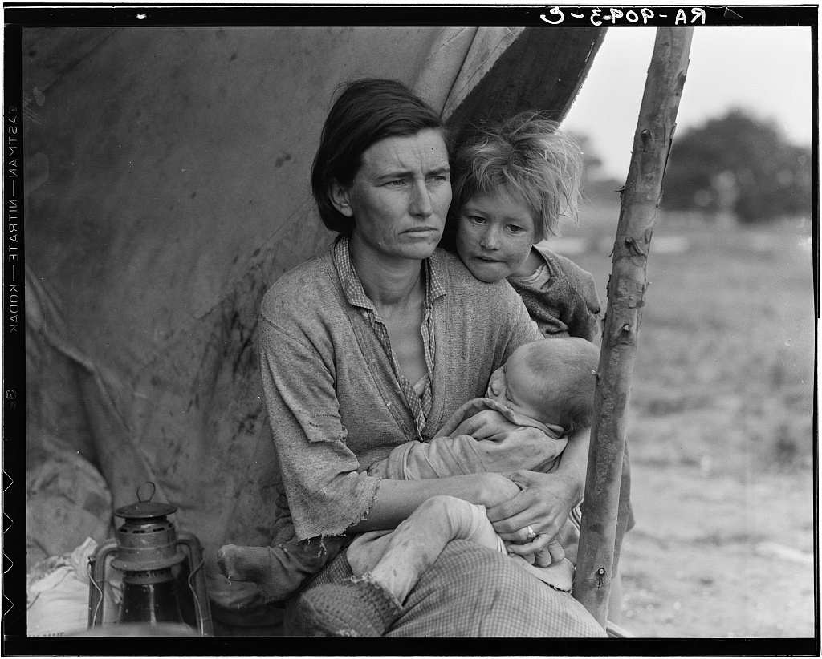  Dorothea Lange. Migrant Mother — frame 3 of 4. Closer still; the children turn away. 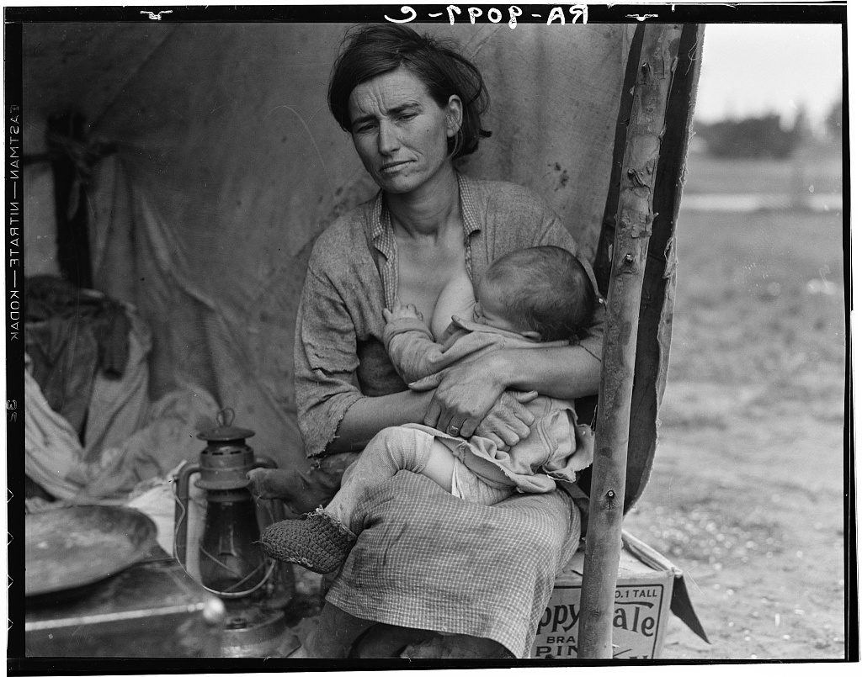  Dorothea Lange. Dust Bowl Farmer with Tractor and Son, near Claud, New Mexico. 1938. 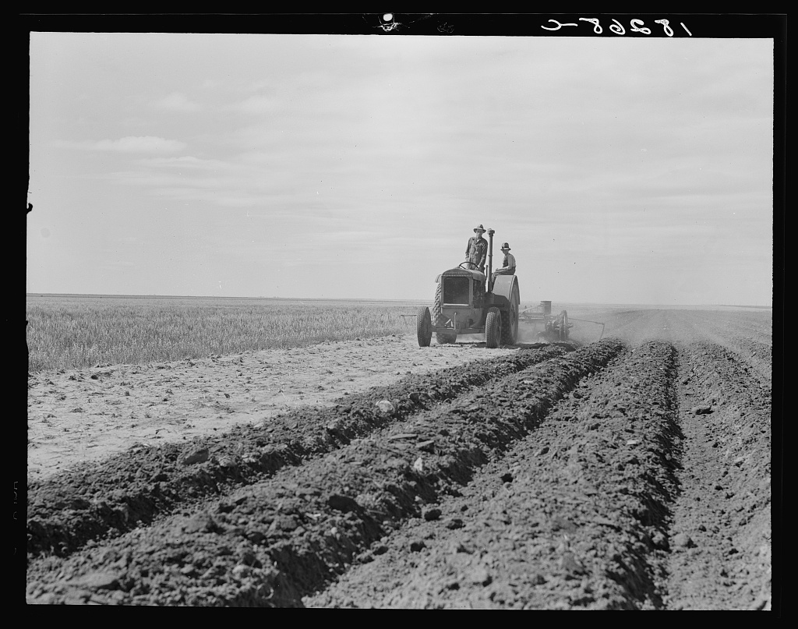  Dorothea Lange. Cotton Picker near Firebaugh, California. Shot at eye level. 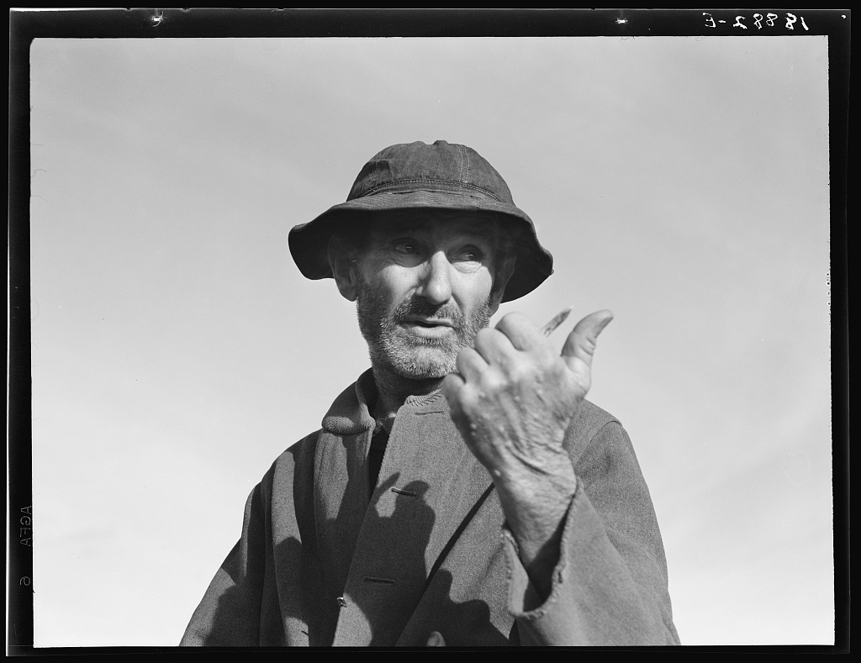  Dorothea Lange. Mother and Three Children in a California Squatter Camp. 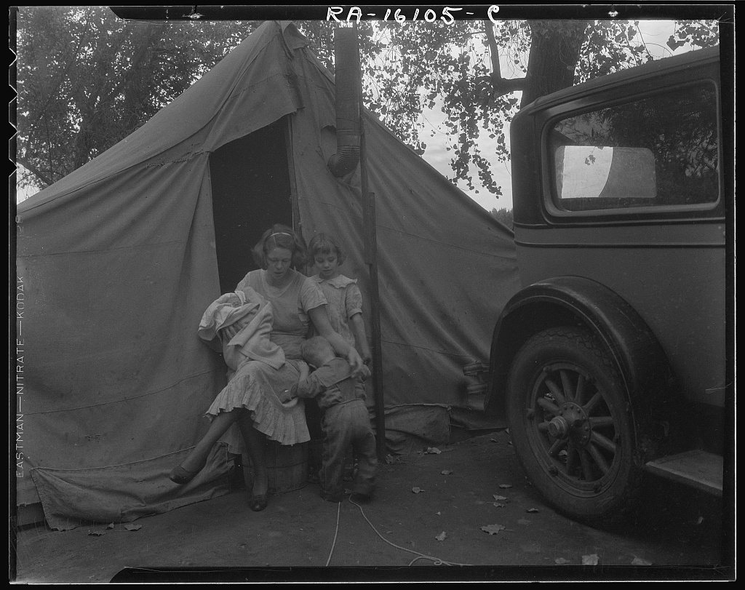  Dorothea Lange. Once a Missouri Farmer, Now a Migratory Farm Labourer on the Pacific Coast. 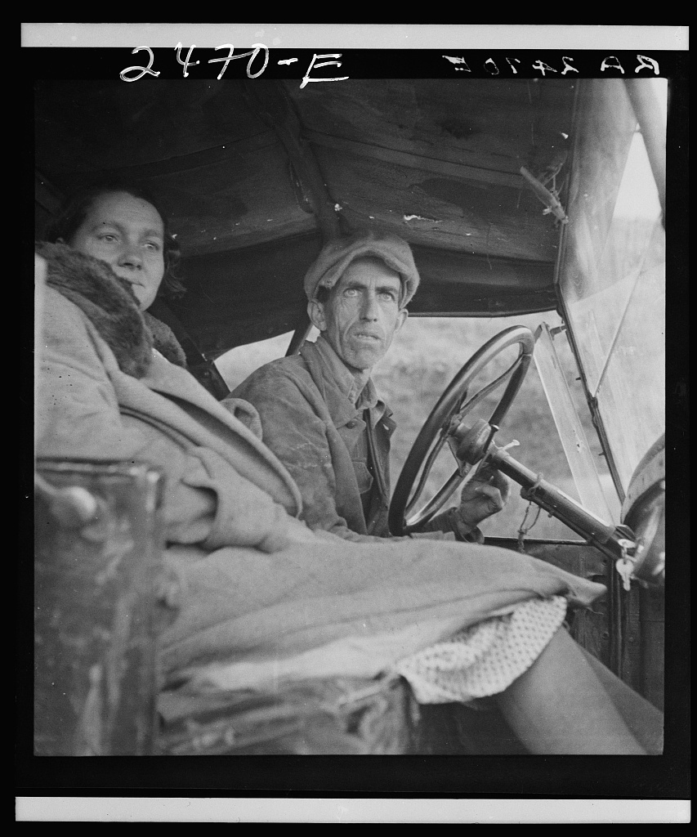  Dorothea Lange. Ex-Tenant Farmer on Relief Grant, Imperial Valley, California. 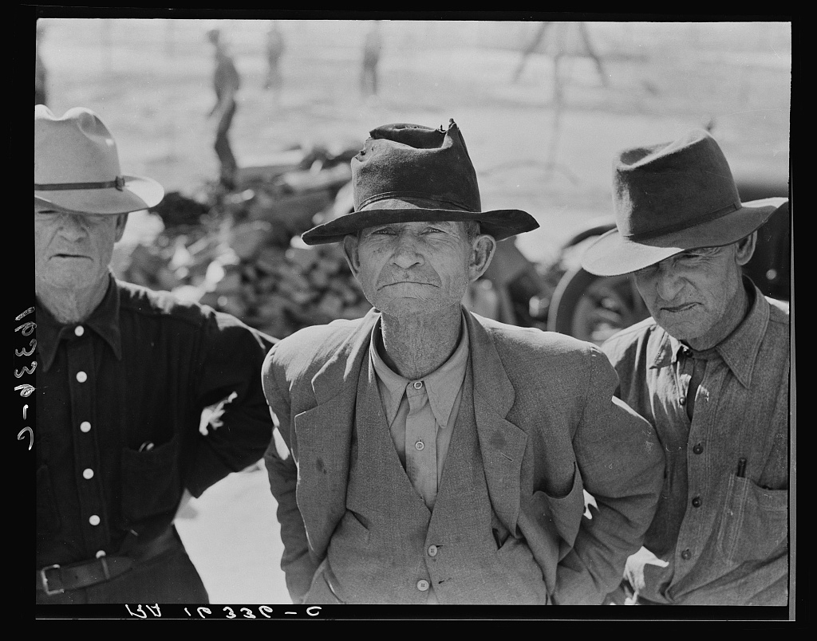  Dorothea Lange. Georgia Road Sign. Language in the landscape. 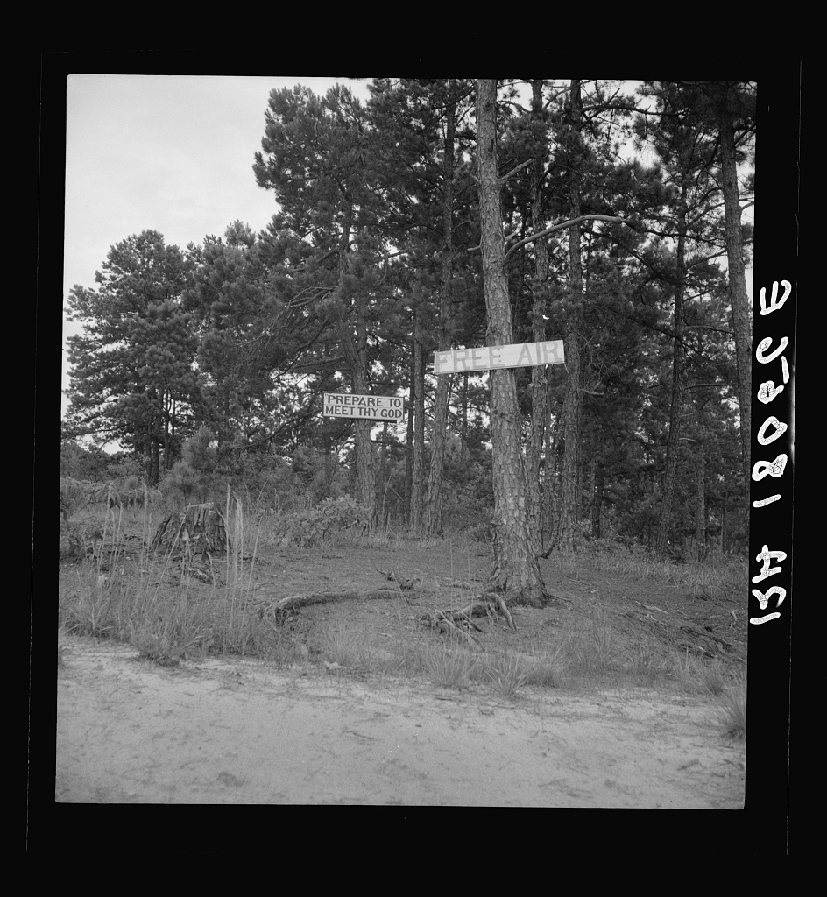  White Angel Bread Line, San Francisco, 1933 (MoMA)  Migrant Mother, Nipomo, March 1936 — plus 3 earlier frames  Damaged Child, Shacktown, Elm Grove, 1936 (MoMA)  Plantation Overseer and his Field Hands, 1936  On the Road to Los Angeles, California, 1937  Funeral Cortege, End of an Era, 1938 (museum print)  Dust Bowl Farmer with Tractor and Son, 1938  Cotton Picker near Firebaugh, California  Mother and Three Children, California Squatter Camp  Once a Missouri Farmer, Now a Migratory Labourer  Ex-Tenant Farmer on Relief Grant, Imperial Valley  Georgia Road Sign  12 photographs; FSA negatives are public domain (LoC).
Film | Y1 Q2 | Representation • Creativity • Transformation | (varies by film selected)  Cinematic techniques, mise-en-scène, and ideological framing.  Interstellar  Interstellar (Nolan, 2014) — PG-13  Science, technology and the environment  Scenes: the dust storm; the docking sequence; Miller’s planet.  Pairs with The Woman in the Dunes.
Art  Edward Hopper | Y1 Q3 | Representation • Perspective • Culture | Culture, identity and community  Urban isolation and the American mid-century imagination.  Nighthawks, 1942 (Art Institute of Chicago)  Automat, 1927 (Des Moines Art Center)  Early Sunday Morning, 1930 (Whitney)  Room in New York, 1932 (Sheldon)  Morning Sun, 1952 (Columbus Museum of Art)  New York Movie, 1939 (MoMA)  In copyright — project from the museum pages.
Advertisements | Y2 Q1 | Communication • Representation • Culture | Nike Purpose, powered by athletes. Nike UK  Identity / Representation  Global issue: Politics, power and justice. Nike frames race, gender, and the athlete-as-outsider  The Dove Self-Esteem Project | Dove  Identity / Perspective  Global issue: Culture, identity and community. Self-image vs. how the world sees you  Environmental Activism - Patagonia  Communication / Perspective.  Global issue: Science, technology and the environment. The anti-consumption paradox; humans against (and inside) nature.  Activism | Ben & Jerry’s  Communication / Culture.  Global issue: Politics, power and justice. Corporate activism as brand identity.  Home - About Us - LEGO.com  Creativity / Representation. Global issue: Art, creativity and the imagination. Play, imagination, and how a brand sells childhood itself.  Ben & Jerry’s — Activism (select specific campaigns)  LEGO — About Us  “Towards a day less war!” — Ad*Access BH1901  “My barber knows women” — Kreml Hair Tonic, 1944,  Cosmopolitan. Ad*Access BH0543. Sells tonic and war bonds.  “Home…” — Ad*Access W0333  World’s Industrial Exhibition, 1853 — Duke EAA A0249  Towards a day less war! / Ad*Access / Duke Digital Repository Representation. Global issue: Culture, identity and community. 1911–1955 ads constructing the "ideal woman" 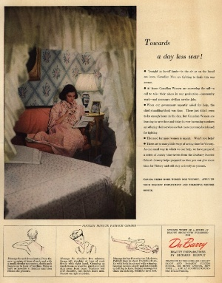  My barber knows women / Ad*Access / Duke Digital Repository 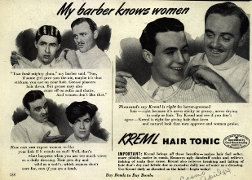  "Home..." / Ad*Access / Duke Digital Repository Communication / Perspective. Global issue: Politics, power and justice. State persuasion engineering fear and loyalty. 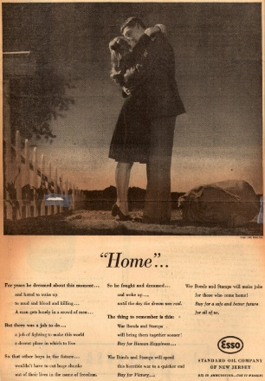  The World's Industrial Exhibition of 1853 -- Season Ticket / Emergence of Advertising in America: 1850-1920 / Duke Digital Repository 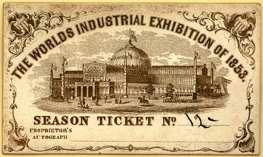 Culture / Representation. Global issue: Culture, identity and community. The birth of the manufactured consumer self.
Infographics (One-Off) | Y2 Q1 | Communication • Representation | Science, technology and the environment  Data visualisation, rhetorical use of statistics, and scientific literacy.  W. E. B. Du Bois — Data Portraits, 1900 Paris Exposition  Our World in Data — CO₂ and greenhouse gas emissions  Bloomberg — What’s Really Warming the World? (2015)  Florence Nightingale — the rose diagram, 1858 (optional)  Du Bois is public domain at the Library of Congress.
Satire / Humor | Y2 Q1 | Communication • Creativity • Perspective | Politics, power and justice  Satire as social and political critique; the rhetoric of irony.  Jonathan Swift, “A Modest Proposal” (1729) — Gutenberg  Key & Peele, “Obama’s Anger Translator” — Comedy Central  Mark Twain, “Advice to Youth” (1882) — Gutenberg  Teacher-vetted satirical headline set  Use the Comedy Central page: the YouTube cut is uncensored.
Speeches | Y2 Q2 | Communication • Perspective • Transformation | Politics, power and justice  Rhetoric, ethos/pathos/logos, and persuasion in public life.  Sojourner Truth, “Ain’t I a Woman?” (1851)  Frederick Douglass, “What to the Slave Is the Fourth  of July?” (1852)  Martin Luther King Jr., “I Have a Dream” (1963)  Malala Yousafzai, UN Youth Assembly (2013)  Greta Thunberg, UN Climate Action Summit (2019)  Spans all five fields. Malala carries Beliefs, values  and education, which no other non-literary text does.
Political Cartoons | Y2 Q2 | Representation • Communication • Perspective | Politics, power and justice  Visual rhetoric, caricature, and ideological framing.  Infographics — W. E. B. Du Bois, Data Portraits (1900)  W. E. B. Du Bois. The Georgia Negro: A Social Study — Occupations. 1900 Paris Exposition. Hand-drawn statistical charts; public domain at the Library of Congress. 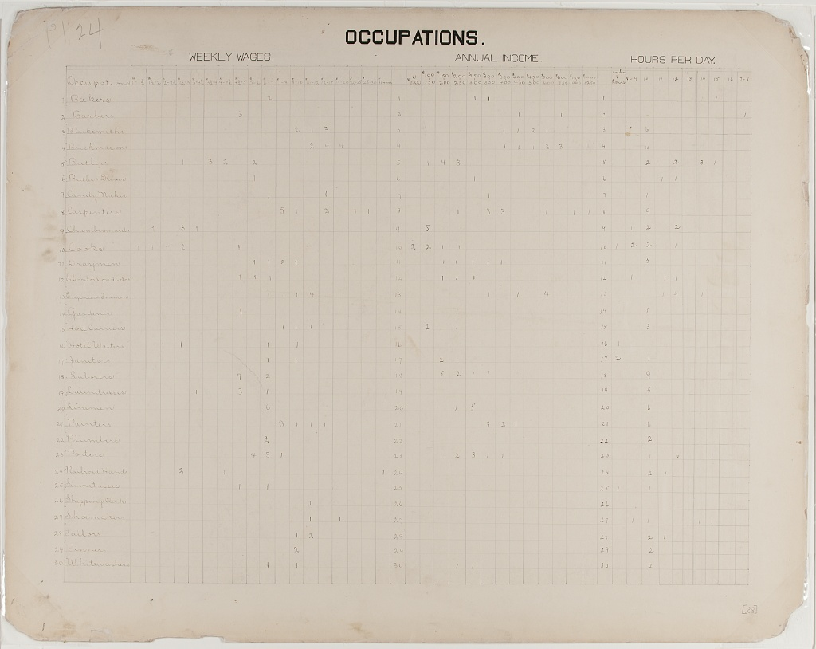  W. E. B. Du Bois. Negro Population of Georgia. 1900 Paris Exposition. 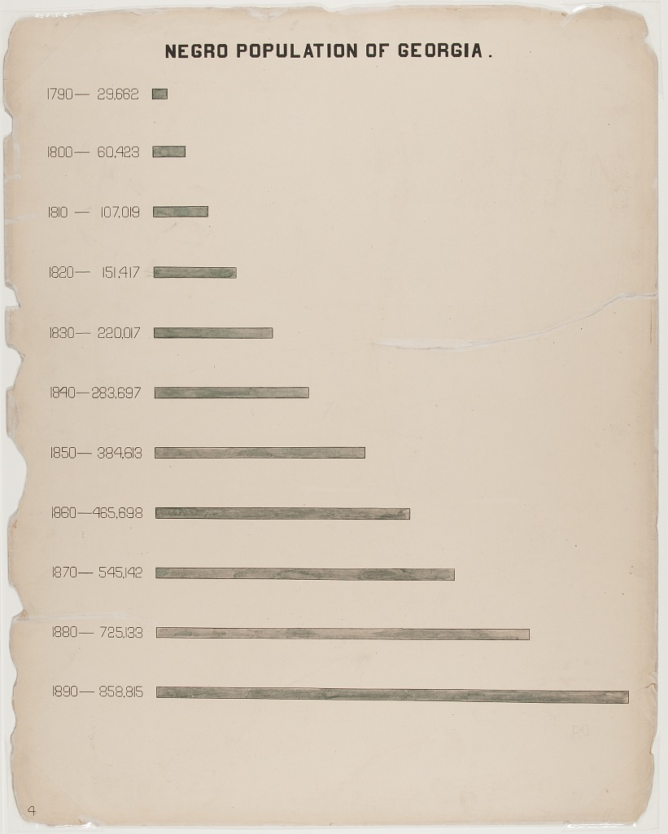  Melican Leportee Man Want Gabbee, ... June 14, 1879, page 476 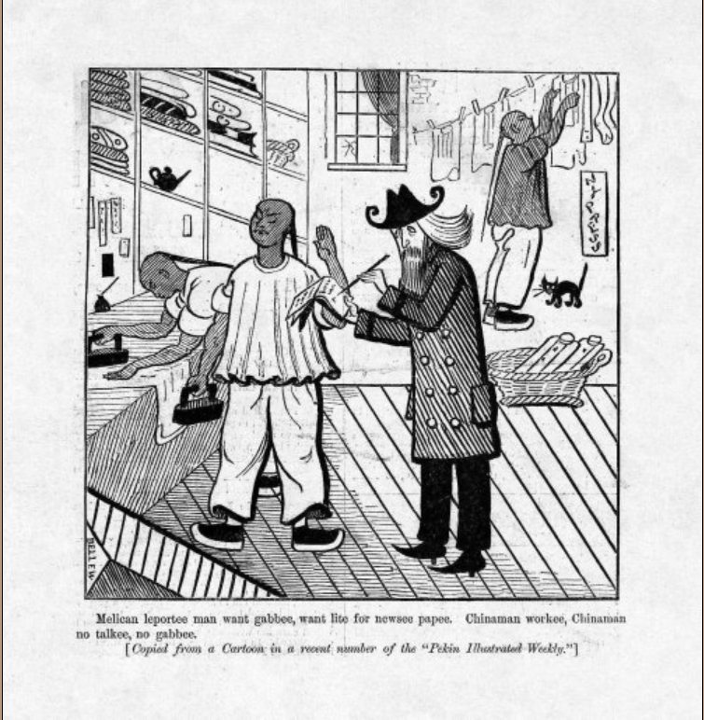  The Rich Growing Richer, the Poor Growing Poorer Harper’s Weekly – September 2, 1871 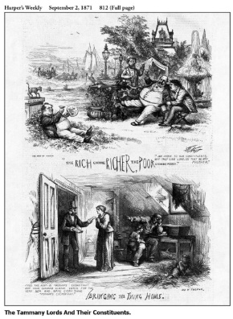  Dave Whamond, Canada / Courtesy of Cagle.com 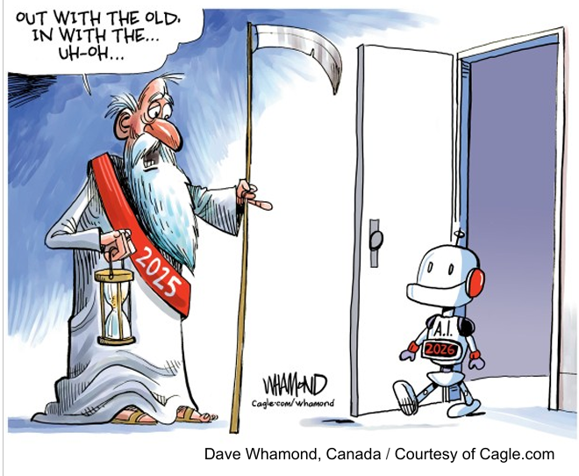  Welcome to All! Joseph Keppler, Puck, 1880. Uncle Sam at the U.S. Ark of Refuge. 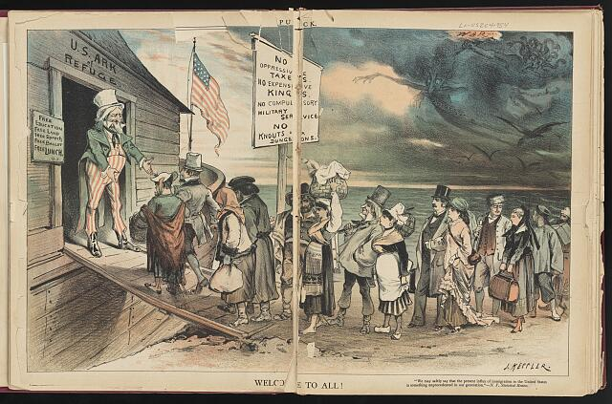  How John May Dodge the Exclusion Act. Puck, 1905. Companion to the Bellew cartoon. Contains ethnic caricature — teach objectively under s. 1000.05. 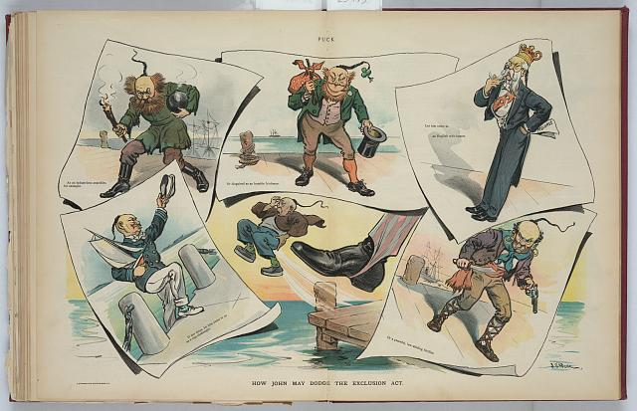  The Americanese Wall — as Congressman Burnett Would Build It. 1916. 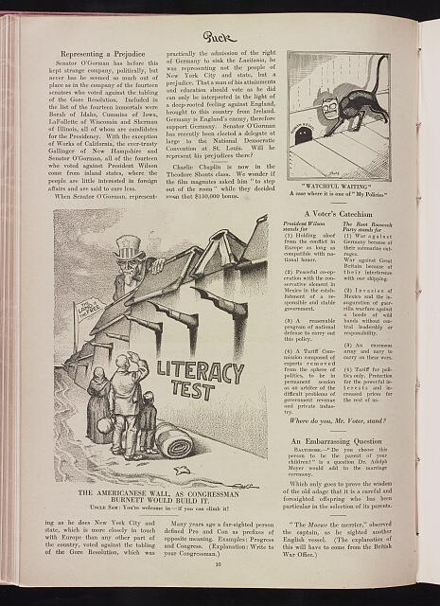  The Fool Pied Piper. Samuel Ehrhart, Puck, 1909. 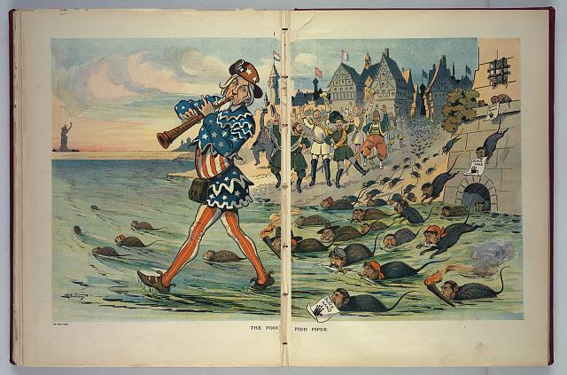  History Repeats Itself — the Robber Barons of the Middle Ages and of Today. Puck, 1889. 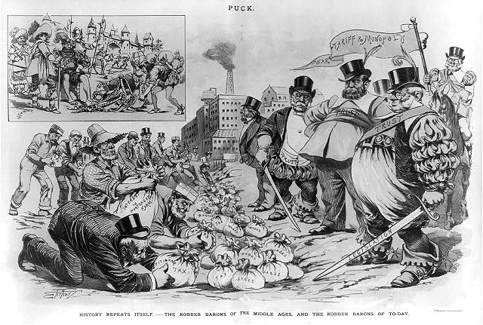  The Open Sesame. Puck, 1896. 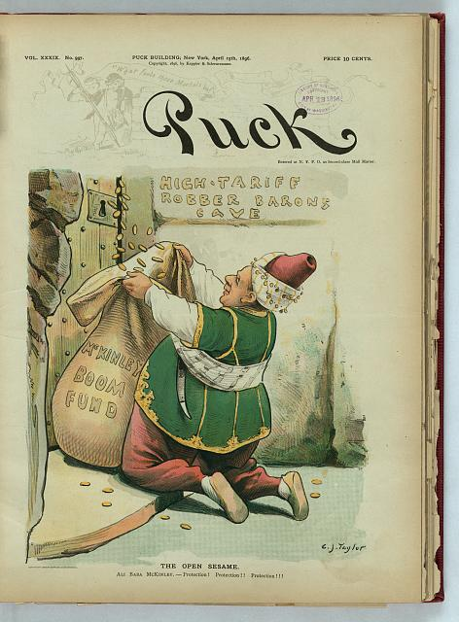  A Squelcher for Woman Suffrage. Puck, 6 June 1894. 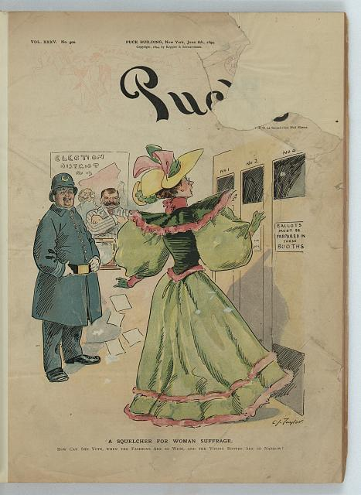  The Apotheosis of Suffrage. 1896. The counter-position to the cartoon above. 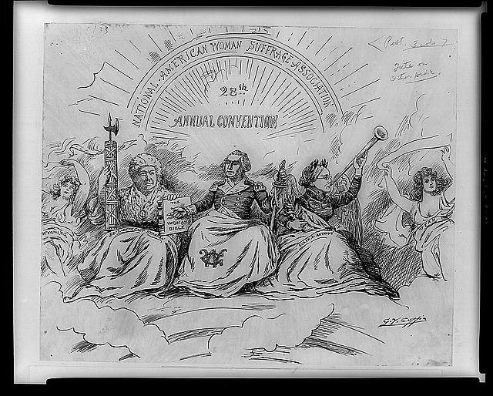  The Fin de Siècle Newspaper Proprietor. Puck, 7 March 1894. 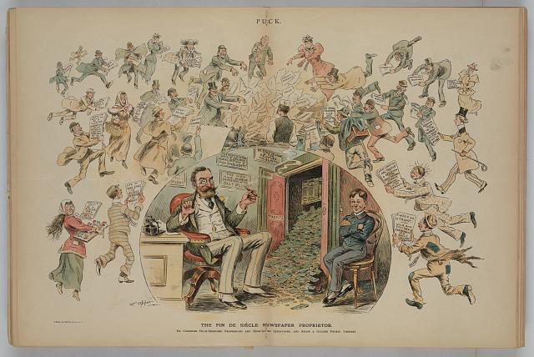  Freedom of the Press. c. 1912. 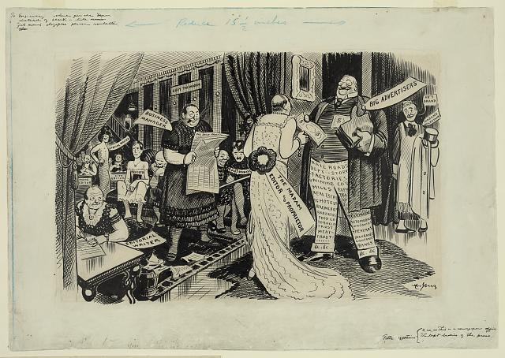  Frank Bellew, “Melican Leportee Man” — Harper’s Weekly,  14 June 1879, p. 476  “The Rich Growing Richer” — Harper’s Weekly, 2 Sept 1871  Welcome to All! — Keppler, Puck, 1880  How John May Dodge the Exclusion Act — Puck, 1905  The Americanese Wall — 1916  The Fool Pied Piper — Ehrhart, Puck, 1909  History Repeats Itself: Robber Barons — Puck, 1889  The Open Sesame — Puck, 1896  A Squelcher for Woman Suffrage — Puck, 1894  The Apotheosis of Suffrage — 1896  The Fin de Siècle Newspaper Proprietor — Puck, 1894  Freedom of the Press — c. 1912  Bellew and How John May Dodge contain racist caricature:  teach objectively under s. 1000.05; log with media specialist.
Websites / Blogs | Y2 Q3 | Communication • Representation • Identity | Science, technology and the environment  Digital identity, hyperlinked rhetoric, and audience construction online.  Climate Change - NASA Science Communication / Representation. Global issue: Science, technology and the environment 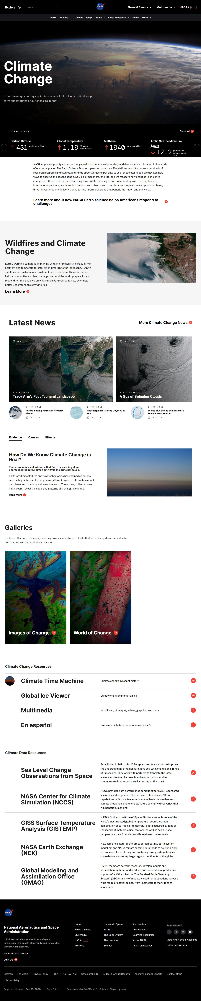  Climate | National Oceanic and Atmospheric Administration Institutional environmental authority constructed through hyperlinked structure — how a site builds credibility (ethos) through navigation, citation, and visual design. Concept: Representation / Perspective.   Climate Change — NASA Science  Climate — NOAA  Humans of New York — use the books, not the feed  The Pudding — pudding.cool  HONY supplies the Identity concept this row claims;  NASA and NOAA do no identity work.

Diploma Program Assessments (HL)
Component | Description & Timing
Paper 1  Guided Textual Analysis | Two guided analyses of previously unseen non-literary extracts or texts.  Timed assessment, completed in school on paper, May of Senior year (May 2028).
Paper 2  Comparative Essay | Four general questions; students write a comparative essay on two works studied (not already used in other assessments).  Timed assessment, in school on paper, May of Senior year (May 2028).
Individual Oral (IO)  Internal Assessment | Supported by an extract from one non-literary text and one from a literary work. Students offer a prepared 10-minute oral response, followed by 5 minutes of teacher questions.  Timing: End of Junior year — Mid March to Mid April 2027. Deadline is non-negotiable. Internally assessed; externally moderated by the IB.
HL Essay  1,200–1,500 words | Essay exploring a line of inquiry connected to a studied text or work.  Worked on through summer between Junior and Senior year and the first half of Senior Year.  Submitted before Winter Break of Senior year (Deadline set by Celebration High School).

Year 1 Breakdown (2026–2027, Junior Year)
Tentative and subject to change. Year 1 culminates in the Individual Oral (IO) assessment in May 2027 and the start of the HL Essay over summer.
Quarter | Study Focus / Works & Texts | Timing & Notes
Q1 | Readers, Writers, and Texts  • Introduction / Course Overview  • Novella: The Tunnel by Ernesto Sabato (PRL, Argentina)  • Music (album lyrics analysis) | Intro: 1–2 weeks  Novella: 4 weeks (~150 pgs)  Music: 3 weeks
Q2 | Readers, Writers, and Texts  • Photography: Dorothea Lange (5–7 photographs) (Non-Lit, 1895–1965, U.S.)  • Film (parent consent required for mature titles)  • Choice Work 1: The Hour of the Star by Clarice Lispector (PRL, Brazil) | Photographs: 3 weeks  Film: 1–2 weeks  Choice Work 1: 4 weeks
Q3 | Time & Space  • Choice Work 2: The Woman in the Dunes by Kōbō Abe (Free choice, Japan)  • Art: Edward Hopper (Non-Lit, 1882–1967, U.S.)  • IO Outline & Practice | Choice Work 2: 4 weeks  Art: 2–3 weeks  IO Practice: 2 weeks  IO Outline due March 1st
Q4 | Intertextuality  • Short Stories (6): Katherine Mansfield (PRL, NZ/UK — free full text)  • IO Assessment  • Begin work on HL Essay (over summer) | Short Stories: 3 weeks  IO Assessment: Mid March to Mid April 2027  HL Essay begins: April–May 2027

Year 2 Breakdown (2027–2028, Senior Year)
Tentative and subject to change. Year 2 culminates in the external IB exams (Paper 1 & Paper 2) in May 2028. The HL Essay is submitted before Winter Break of Senior Year.
Quarter | Study Focus / Works & Texts | Timing & Notes
Q1 | Time & Space  • Othello by William Shakespeare (PRL, UK, 1622) — Folger edition with paired texts  • Speeches (Non-Lit)  • Political Cartoons  • Paper 1 & Paper 2 practice | Othello: 3 weeks  Speeches: 2 weeks  See Folger resources section
Q2 | Readers, Writers, and Texts  • T. S. Eliot — Selected Poems (19 poems, 1911–1930) (PRL, U.S./UK)  • Advertisements (Non-Lit)  • Infographics (One-Off)  • Satire / Humor  • Finalize HL Essay  • Paper 1 & Paper 2 practice | Eliot: ~2 weeks  Advertisements: 2 weeks  Infographics: 2 weeks  HL Essay due before Winter Break (Dec 2027)
Q3 | Intertextuality / Review  • Review of previous works & Learner Profiles  • Websites / Blogs (Non-Lit)  • Paper 1 & Paper 2 practice | Review of all 6 works  Targeted Paper 1/2 prep
Q4 | Exam Preparation  • Review of previous works & Learner Profiles  • Paper 1 & Paper 2 practice  • Final timed assessments | Paper 1 & Paper 2: May 2028  IB exams in school, on paper

T. S. Eliot — Selected Poems (PRL)
Poems are studied in Year 2, Quarter 1 (~2 weeks). All 19 poems below are accessible online. Wikisource and Poetry Foundation links are stable, ad-free, and classroom-friendly.
Poem | Year | Access Link
The Love Song of J. Alfred Prufrock | 1915 | Read on Poetry Foundation
Preludes | 1911 | Read on Poetry Foundation
Portrait of a Lady | 1915 | Read on Wikisource
Rhapsody on a Windy Night | 1915 | Read on Wikisource
Morning at the Window | 1915 | Read on Wikisource
The Boston Evening Transcript | 1915 | Read on Wikisource
Aunt Helen | 1915 | Read on Wikisource
Cousin Nancy | 1915 | Read on Wikisource
Mr. Apollinax | 1916 | Read on Wikisource
La Figlia Che Piange | 1916 | Read on Wikisource
Sweeney Among the Nightingales | 1918 | Read on Wikisource
Whispers of Immortality | 1918 | Read on Wikisource
Burbank with a Baedeker: Bleistein with a Cigar | 1919 | Read on Wikisource
Gerontion | 1920 | Read on Wikisource
Eyes that last I saw in tears | 1924 | Read on Poetry Nook
The Hollow Men | 1925 | Word Doc
Journey of the Magi | 1927 | Word Doc
Animula | 1929 | PDF
Marina | 1930 | Word Doc

Authors (Background & Context)
- Ernesto Sabato (Britannica)
- Clarice Lispector (Penguin Random House)
- Kōbō Abe (Britannica)
- Katherine Mansfield — all free ebooks (Project Gutenberg)
- Dorothea Lange (MoMA)
- Edward Hopper (Whitney Museum)

